**Coordinate system**

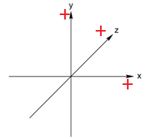

Pov-Ray follows a left-handed coordinate system. If one stretches the thumb, index finger, and middle finger of left hand, each towards the x,y, and z directions as the picture 1 (left), the tips of each finger point to the positive direction of the axes in a 3D coordinate system of Pov-Ray image.

**Background**

A variety of choices for colors can be found at the top menu of the POV-Ray software under the ‘Insert / Colors’ tab. Prior to the color selection, POV-Ray version must be specified and “color.inc” must be included. The Adelson checkerboard uses ‘Gray50’ as the image below:



#version 2.5

#include "colors.inc"

Background { color CHOICE}

**Basic objects**

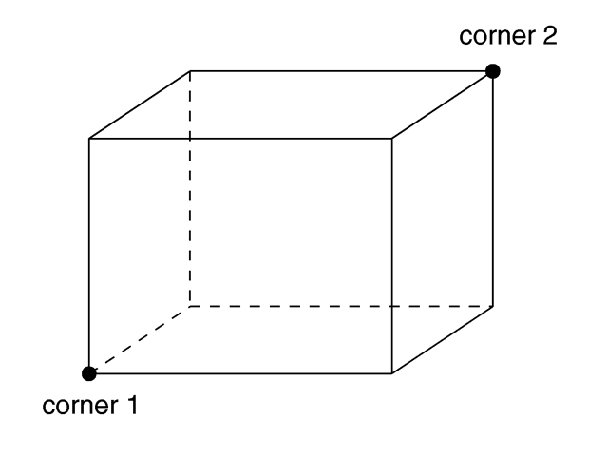

1. Board

box {

<Corner_1>, <Corner_2>

[OBJECT_MODIFIERS...]

}

1.1 Color

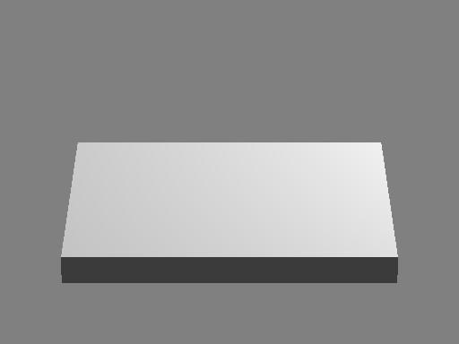The ‘pigment { }’ argument inside the “OBJECT_MODIFIERS” slot is used to fill an object with one or more specified choice of color or pattern. For example:

checker

color <2.3,2.3,2.3>

color <2.3,2.3,2.3> * 0.265

color rgb <2.3,2.3,2.3>

color rgb <2.3,2.3,2.3> * 0.265

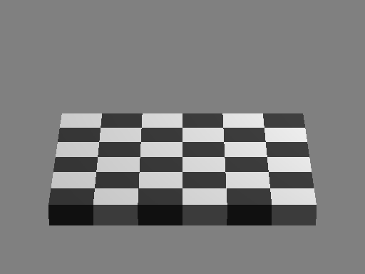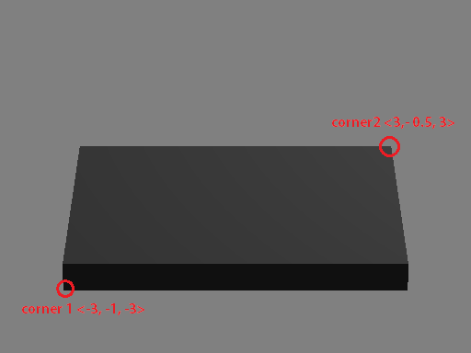

1.2 Rotation

An object can be rotated by placing the argument, ‘rotate AXIS * Θ ’, right after the argument specifying it. The Adelson checkerboard is rotated -45 degrees around the z-axis. For example:

Box { … } rotate y * -45

Box { … } rotate z * -45

Box { … } rotate x * -45

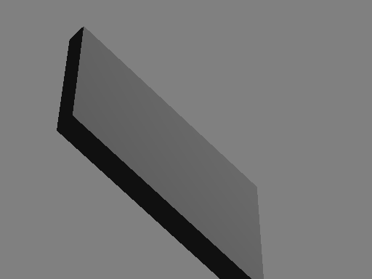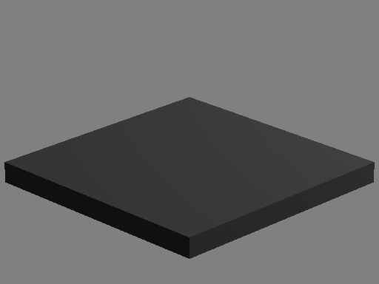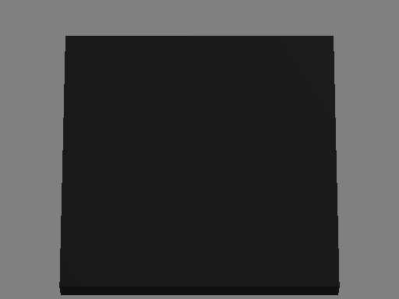

1.3 Number of checks

The number of checks on a checkerboard can be specified with the ‘scale { }’ argument inside the ‘pigment { }’ argument of the box object argument.

box{

<-3, -0.6, -3>

< 3, -0.3, 3>

pigment {

checker

color <2.3, 2.3, 2.3>

color <2.3, 2.3, 2.3> * 0.265

scale <x,y,z>

}

}

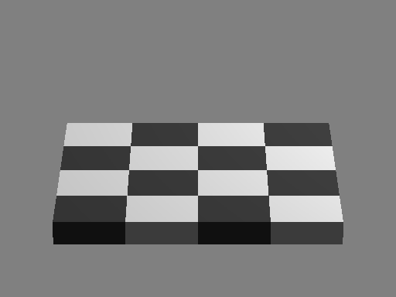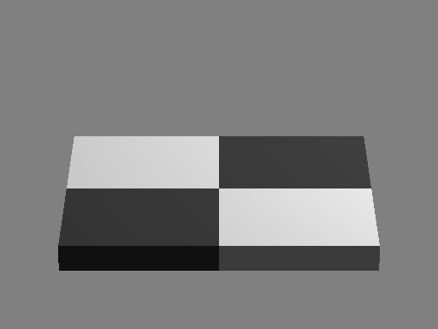

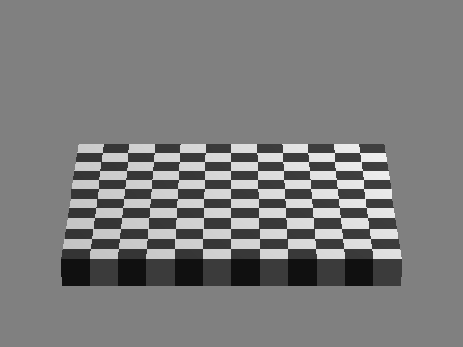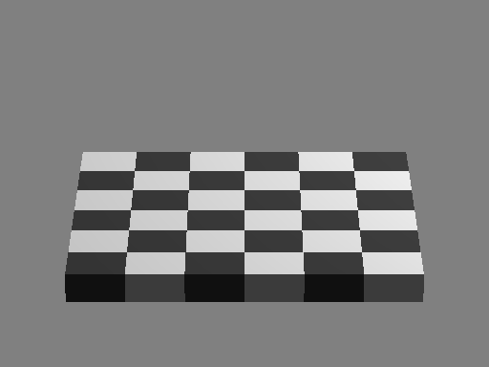The number of checks on a board can be manipulated by varying the scales of x-axis and z-axis with a same value. More precisely, the scale vector determines the size of a single check.

scale <3, 1, 3>

scale <1.5, 1, 1.5>

For example, the example boards on the left are constructed with a different number of checks with scalar multiple of 3, since they all have lengths of 6 in both x and z directions.

scale <0.5, 1, 0.5>

scale <1, 1, 1>

1. Cylinder

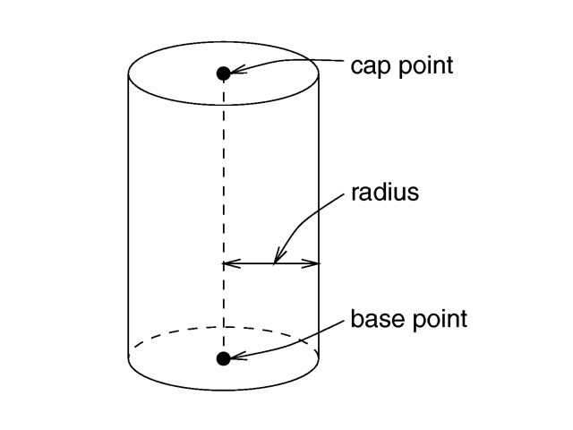

Cylinder {

<Base_Point>, <Cap_Point>, Radius

[ open ] [OBJECT MODIFIERS]

}

A cylinder object needs three main specifications: base and cap points that determine the location on an image and the height, and a radius that determines the width. The cylinder in the original Adelson checkerboard script is shown below:

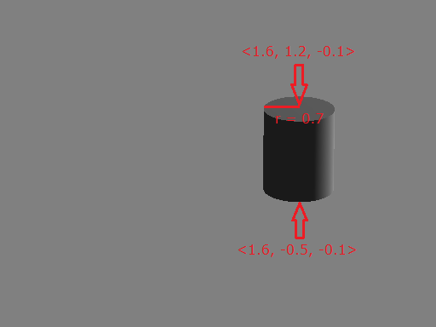e.g.

cylinder{

<2.8, -0.5, 0.3>

<2.8, 1.2, 0.3>

.7

pigment{ rgb <1.0, 1.0, 1.0> }

translate <-1.2,0,-.4>

}

An additional parameter, ‘translate <x,y,z>’, is used to move about the cylinder in accordance with the Pov-Ray coordinate system. The above script can be re-written as below:

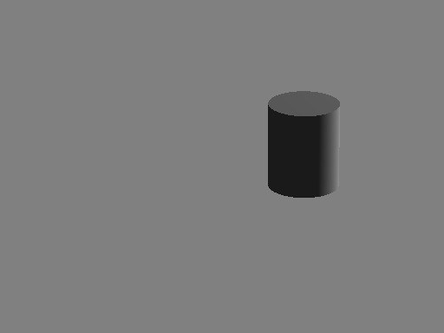

Cylinder {

<0, 0, 0>

<0, 1.7, 0>

.7

pigment{ rgb <1.0, 1.0, 1.0> }

translate <1.6,-0.5,0.3>

}

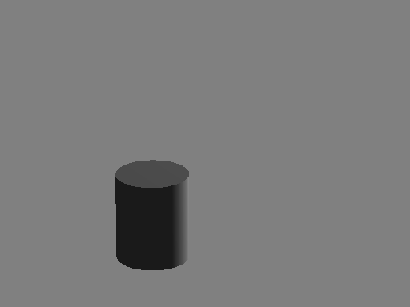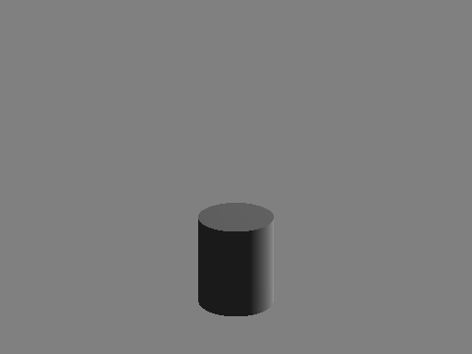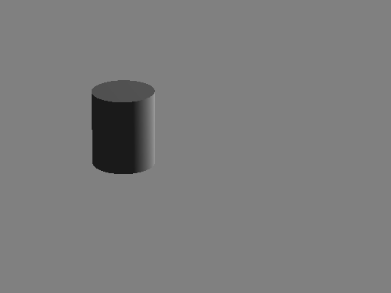

translate <-1.6,-0.5,0.3>

translate <0,-2.5,0>

translate <-1.0,0,-5.3>

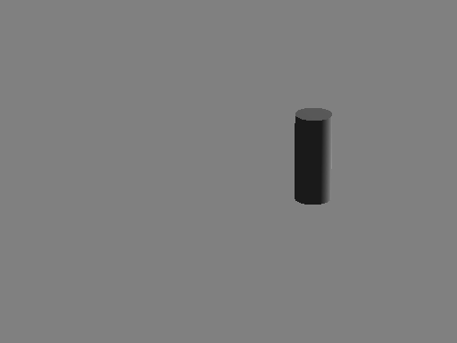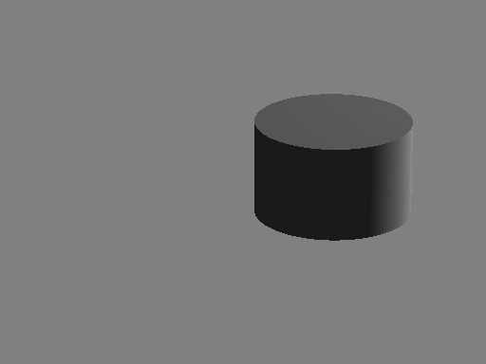

radius = 1.4

radius = 0.35

**Light source**

light_source {

<Location>, COLOR

[LIGHT_MODIFIERS...]

}

1. Point light

The point light takes only two parameters: location and color. However, it only varies the intensity othe light, because the point light source illuminates every object on an image equally.

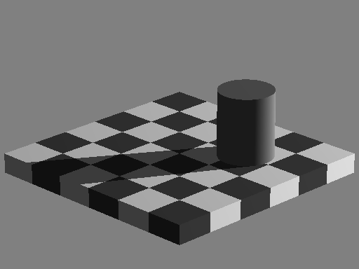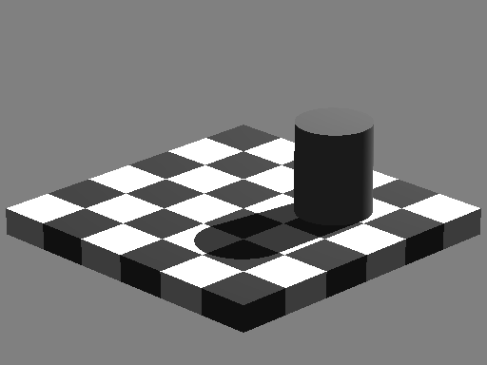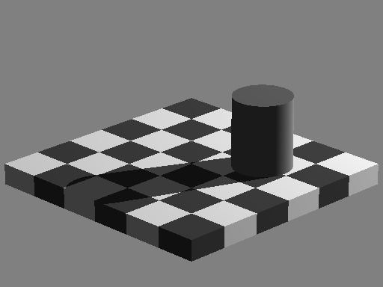

<10, 10, 7>

<20, 10, 7>

<30, 10, 7>

1. Spotlight

The spotlight source radiates light from the source location (‘location’) in a cone-shaped fashion. There are four important parameters: point_at, radius, and falloff. When the spotlight hits an object, it produces a bright circle of light with specified center coordinate (‘point_at’) and radius angle (‘radius’) and a ring of dimmer light that surrounds it. The edges of the outer ring are defined by a falloff angle (‘falloff’).

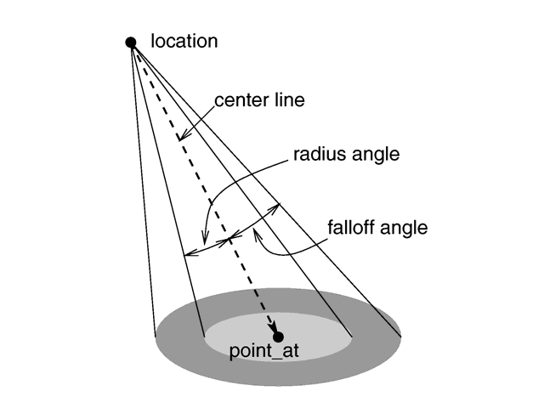

light_source {

<Location>, COLOR

spotlight

point_at <x,y,z>

radius X

falloff X

}

The three scenes below are generated with spotlights of radius = 3, falloff = 5, and tightness = 0, pointed at the center of the cylinder’s cap point, <1.6, 1.2, -0.1>. The coordinates on the top left of each image indicates the location of a light source.

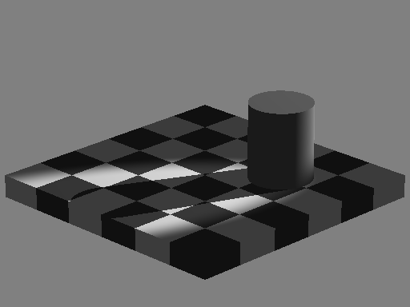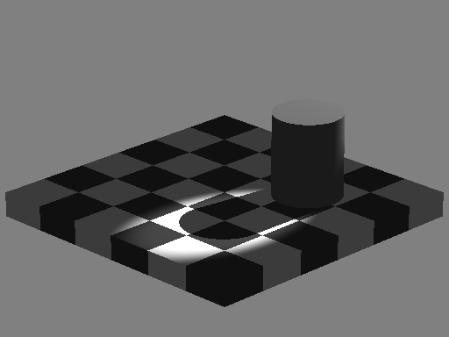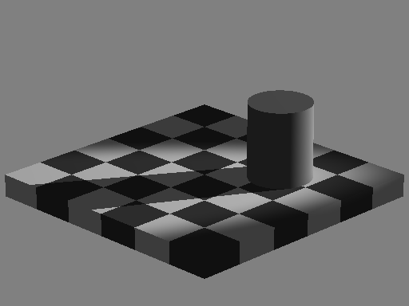

<30, 10, 7>

<10, 10, 7>

<20, 10, 7>

The three images below are generated with spotlights of radius =1 and varying falloffs. The light source is located at <20, 10, 7> and is pointed at <0, 0, 0>.

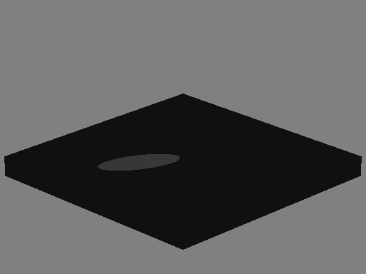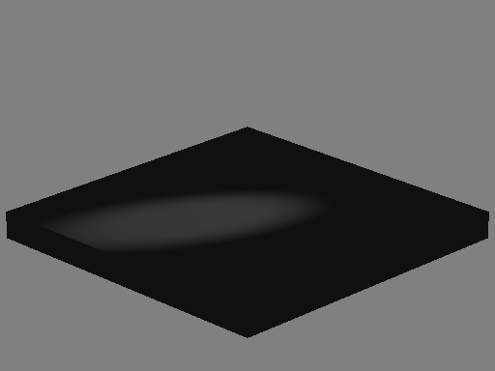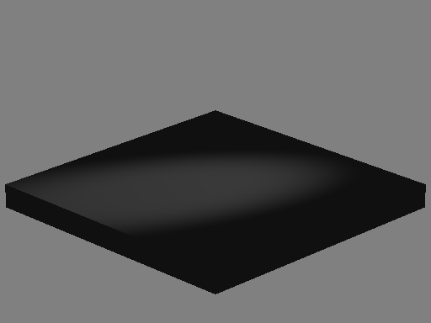

falloff = 5

falloff = 3

falloff = 1

Unlike the point light source, the spotlight can be used to illuminate a specific region.

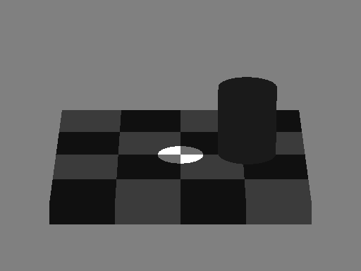

light_source {

<0,10,0>, color White

spotlight

point_at <0,0,0>

radius 3

falloff 3

}

The spotlight can be used to cast a light on a specified location (i.e. a single check) as shown in the two images below:

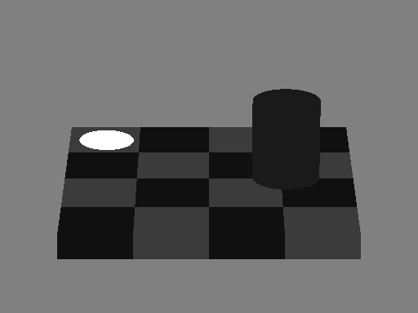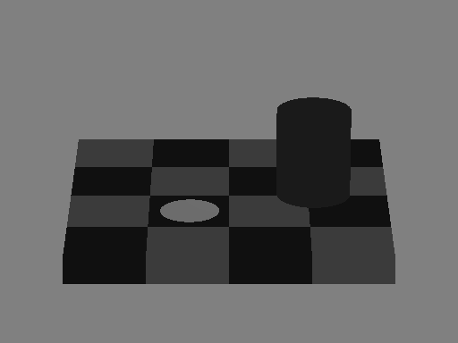

radius = 3

falloff = 3

Note that light sources are located at <20,10,7> in both images above.

The ‘falloff’ command can be used to produce an effect of blurring edge as the image below:

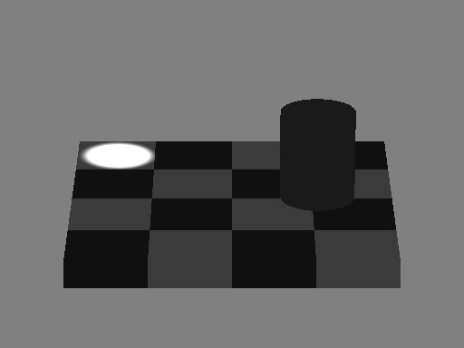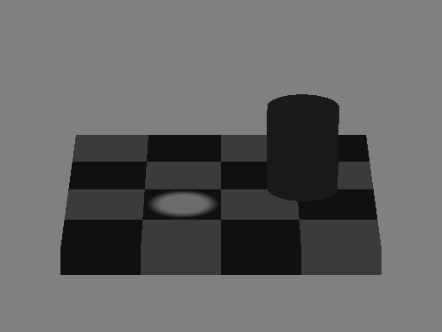

radius = 2

falloff = 4

1. Area light

light_source {

LOCATION_VECTOR, COLOR

area_light

AXIS_1_VECTOR, AXIS_2_VECTOR, Size_1, Size_2

[ [LIGHT_MODIFIERS...]

}

The area light is constructed by an array of multiple point light sources. It radiates from a rectangular- shaped grid source with a center (‘location_vector’) and lengths and directions of the edges (‘axis_1’ and ‘axis_2’ only in x and z axis). The number of point light sources on a grid is specified by the product of two integers (‘size_1’ and ‘size_2’). Since there are multiple light sources, the resulting illumination may create multiple shadows for an object.

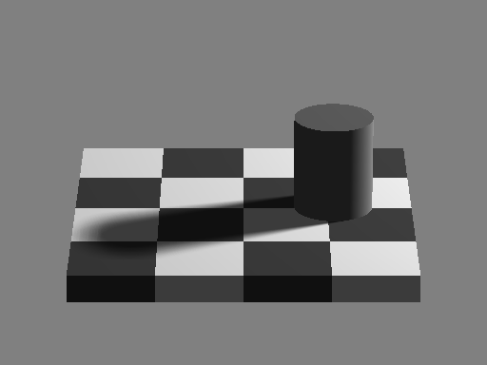

light_source {

<20,10,7>, color White

area_light

<3,0,0>, <0,0,3>, 12, 12

}

The area light is constructed with a total of 144 (12x12) point sources on a grid. The resulting shadow of the cylinder looks smooth, since there were a lot of shadows that overlay each other.

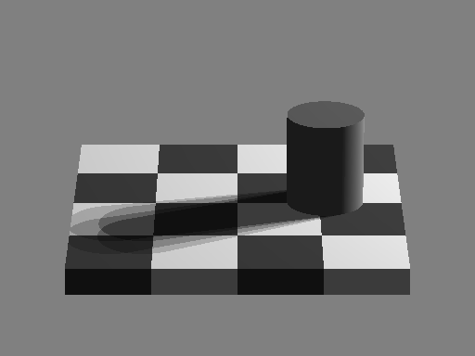

light_source {

<20,10,7>, color White

area_light

<3,0,0>, <0,0,3>, 2, 2

}

The area light is constructed with a total of 4 (2x2) point sources on a grid. All the four shadows of the cylinder are visible.

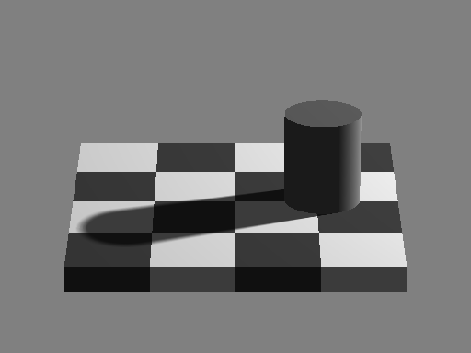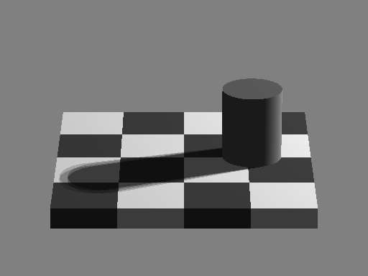

<1,0,0>, <0,0,1>, 12, 12

<1,0,0>, <0,0,1>, 2, 2

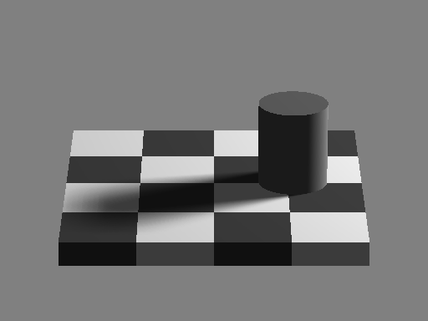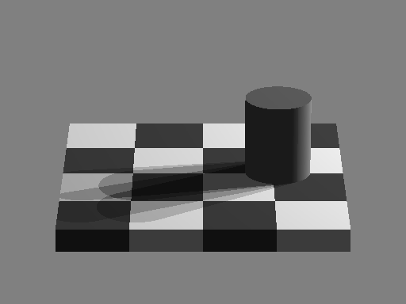

<6,0,0>, <0,0,6>, 2, 2

<6,0,0>, <0,0,6>, 12, 12

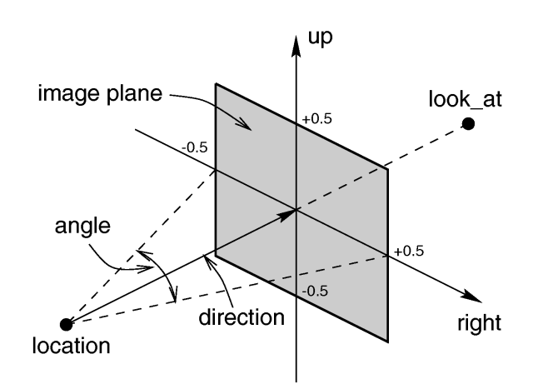**Camera**

Camera {

Location <x,y,z>

Up <x,y,z>, Right <x,y,z> (optional)

Look_at <x,y,z>

Angle Θ

}

An image can be viewed at different angle by placing a POV-ray camera to a desired location. As shown above, only the image that falls inside a specified image plane is projected onto a screen. An image plane can be specified with the following four parameters: location vector that specifies the viewing position, up and right vectors that specify the size of an image plane, look_at vector that specifies the focus point on an image, and angle vector that specifies the viewing angle. However, a simple 3-dimensional checkerboard can be constructed with only three parameters: location, look_at, and angle, which can be treated as a zooming in/out function.

1. Varying location

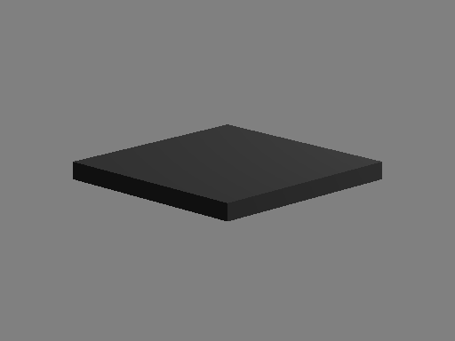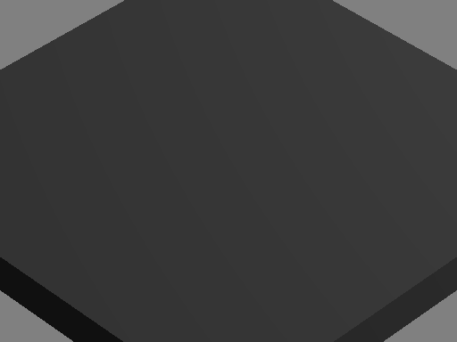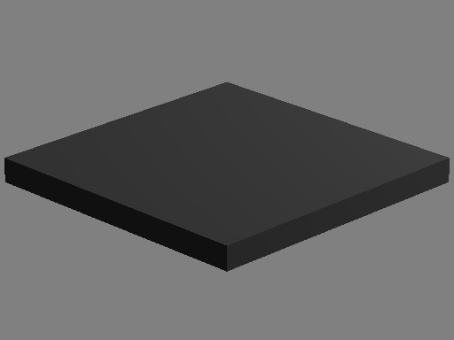

location <0, 20, -75>

look_at < 0, 0, 0>

angle 9.2

location <0, 20, -25>

look_at < 0, 0, 0>

angle 9.2

Camera {

location <0, 20, -50>

look_at < 0, 0, 0>

angle 9.2

}

1. Varying look_at

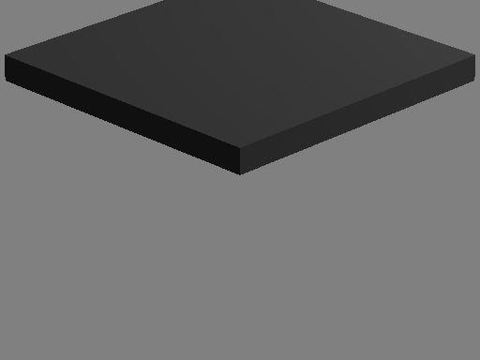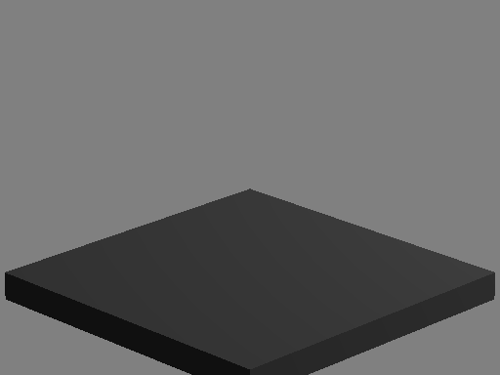

location <0, 20, -50>

look_at < 0, 0, 5>

angle 9.2

location <0, 20, -50>

look_at < 0, 0, -5>

angle 9.2

Camera {

location <0, 20, -50>

look_at < 0, 0, 0>

angle 9.2

}

1. varying angle

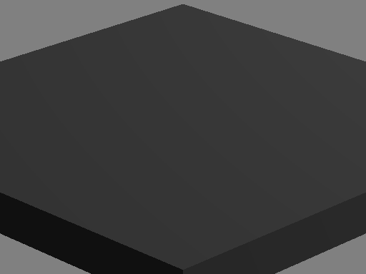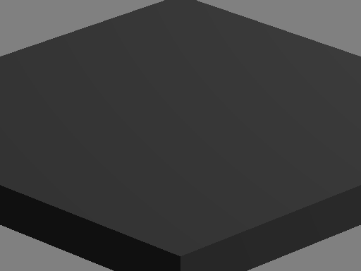

location <0, 20, -25>

look_at < 0, 0, 0>

angle 9.2

location <0, 10, -25>

look_at < 0, 0, 0>

angle 9.2

location <0, 20, -50>

look_at < 0, 0, 0>

angle 4.6

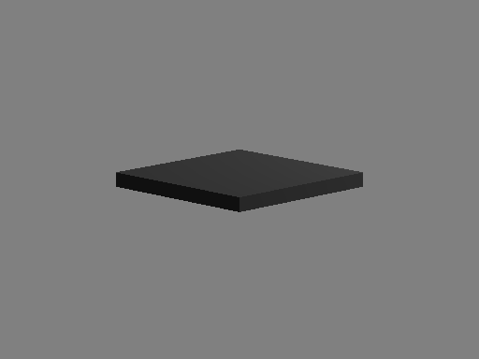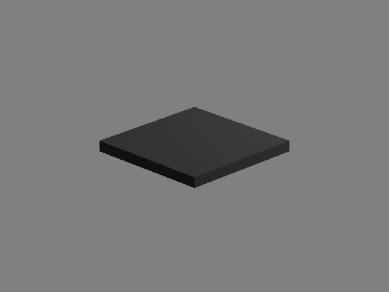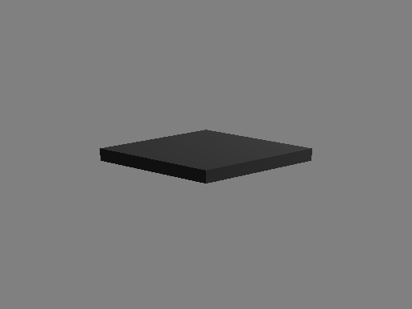

location <0, 20, -50>

look_at < 0, 0, 0>

angle 18.4

location <0, 20, -100>

look_at < 0, 0, 0>

angle 9.2

location <0, 40, -100>

look_at < 0, 0, 0>

angle 9.2